Q1)
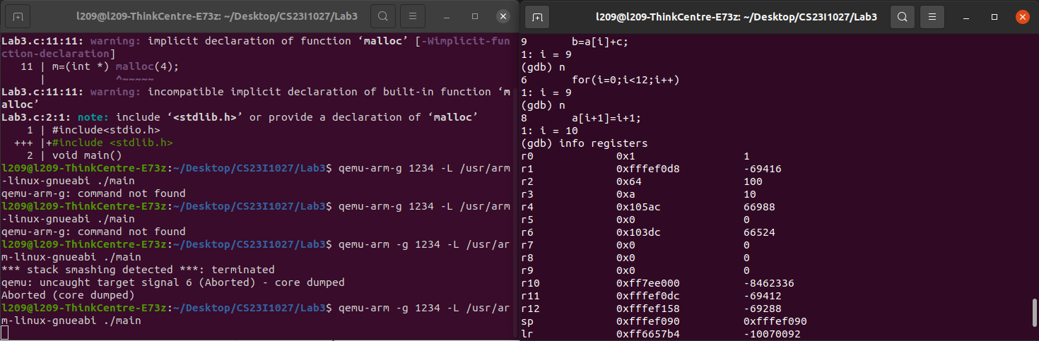
r5 = 0

Q2)
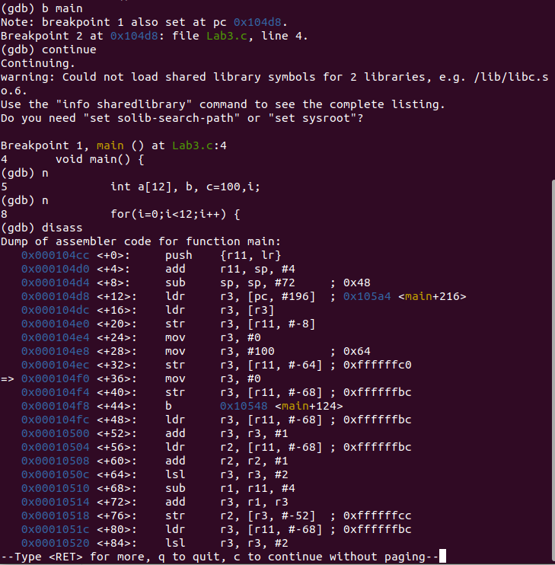
Stack is accessed 3 times, in 0x000104d0 frame and 0x000104d4 frame.
Once in addition, Once in Accessing while subtracting and once while subtracting itself.

Q3)
Since it is using malloc, Heap memory is being accessed.

Q4)
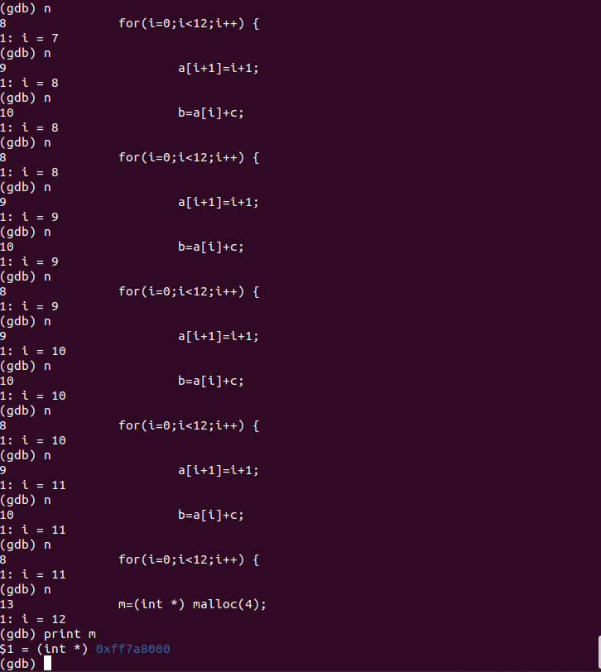
If the value is NULL, the allocation failed. Here it is not NULL.
(gdb) break malloc
watch *m
print m
info locals

